FocusMe for Outlook  
VBA Version

***Focusing on the work rather than your Microsoft Outlook Inbox***

|  |
| --- |
| User Manual |

***Contact Information:***

800-942-4625 x700  
support@ceptara.com

Table of Contents

Introducing FocusMe for VBA 3

How to Install 4

Installation – Part One 4

Installation – Part Two 4

How to Use 6

First Time It Starts 6

FocusMe Task Pane 7

Creating Projects 8

5D Processing Email 14

Managing Tasks 15

Time Tracking 19

Settings – Application Options 21

More Information 23

Reference Materials 23

FocusMe for Outlook - .net Version 23

# Introducing FocusMe for VBA

The FocusMe tool is a Visual Basic for Applications (VBA) application built within Microsoft Outlook. It is a collection of several VBA macros designed to help maintain focus on important action versus the everyday flow of email. It is designed so that one can escape their email inbox and focus on getting the important work done by enhancing and better utilizing Outlook’s capabilities.

The tool contains several abilities or shortcuts:

* Create tasks & appointments from incoming email quickly
* Easily file incoming email to get to [Zero Inbox](https://whatis.techtarget.com/definition/inbox-zero)
* Use projects (categories) to organize your work, i.e. tasks, appointments, email, etc.
* Track, manage and communicate with people assigned to projects in one view
* Track, find, and manage relevant tasks for driving actions and achieve your goals.
* Track, manage and connect email conversations back to tasks to facilitate more productive work achievement
* Use your calendar to track time spent on each project.
* Group projects into workspaces to consolidate time tracking.

The tool is built on VBA which makes it easier to install when one doesn’t have admin privileges to their personal computer.

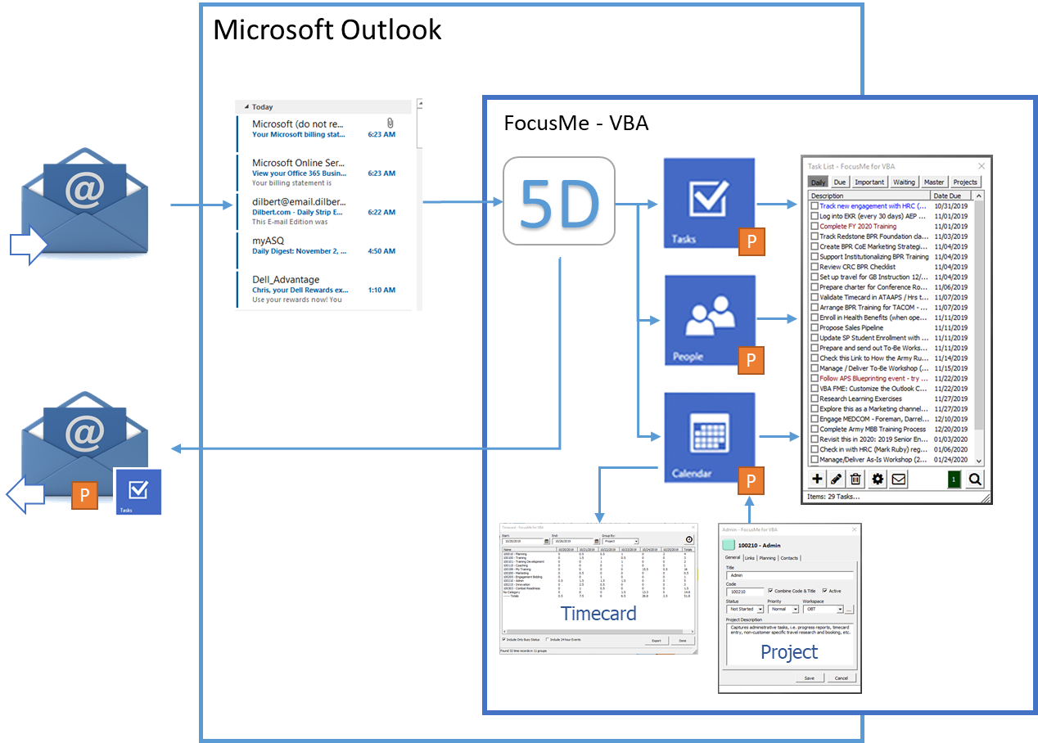

Figure - FocusMe Concept

# How to Install

Microsoft Outlook stores its Macros in a file called “VBAProject.OTM”, located in the directory:  
C:\Users\{WindowsUserName}\AppData\Roaming\Microsoft\Outlook. Outlook uses XML formatted files to customize the Ribbon user interface.

There are three files in the FocusMe Release package (compressed into the zip file);

1. The binary VBA macros – i.e. VBAProject.OTM
2. An XML formatted file that defines the user interface buttons – i.e.   
   20190821 Outlook Customizations (olkexplorer).xml
3. Instructions on how to install and use the macros (FME-VBA Manual.pdf)

## Installation – Part One

Install the VBA Macros File

1. Shutdown Outlook
2. Copy the latest zip file to the local desktop, e.g. 20171017 Release.zip
3. Open the Zip file, and select Extract All  
   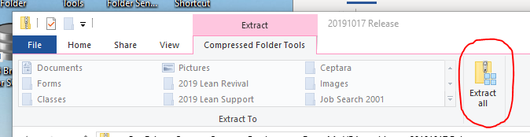
4. From the newly created Folder (generated from the Extract All)
   1. Copy the ‘VBAProject.OTM’ file you just downloaded via the Zip file to the Microsoft Outlook AppData directory -   
        
      C:\Users\{WindowsUserName}\AppData\Roaming\Microsoft\Outlook
5. Start Outlook
6. When you see the Microsoft Outlook Security Notice, select the ‘Enable Macros’ button – this should automatically start the FME Task List window.

## Installation – Part Two

Install the XML UI file

1. Make sure Outlook is running
2. From the Outlook main window, select the ‘FILE’ tab
3. Select the ‘Options’ menu item, this should start the Outlook Options dialog
4. Select ‘Customize Ribbon’, press the Import/Export button – Import Customization file option
5. In the File Open dialog, select the UI XML file that you extracted in step 5 above, i.e.  
   20190821 Outlook Customizations (olkexplorer).xml
6. Select Open
7. Look for the FocusMe group added to the Home (Mail) tab  
     
   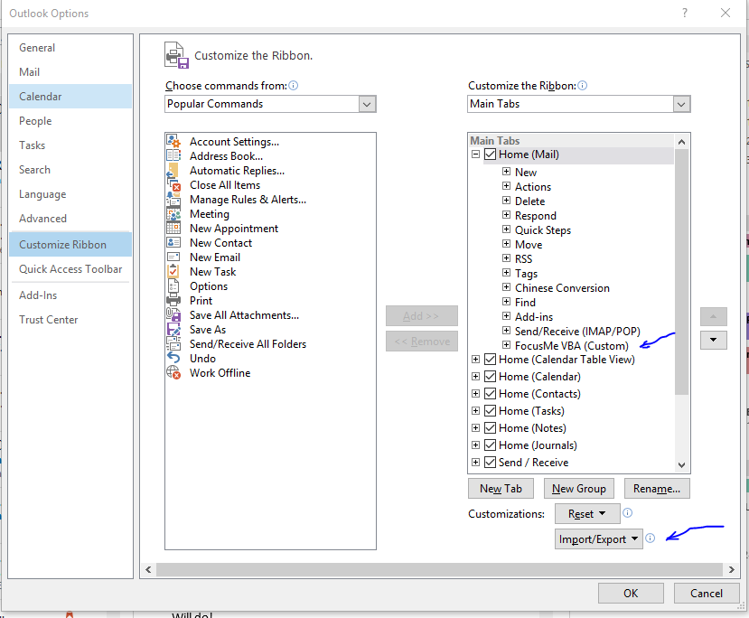
8. This will add a FocusMe VBA group and 5D Processing button to the Mail Home tab, and a Timecard button to the Calendar Home tab

### Calendar Home Tab

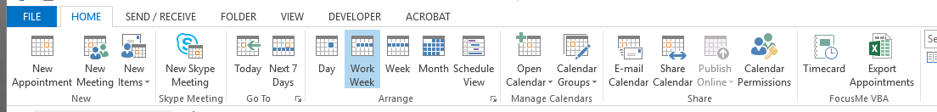

### Mail Home Tab

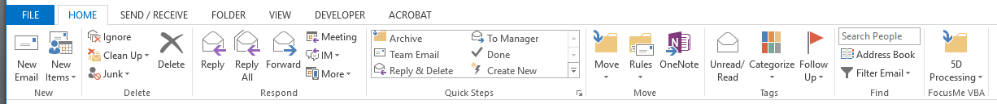

# How to Use

The following provides a screenshot guide to using FocusMe for VBA.

## First Time It Starts

The first time the FocusMe app is run, it will present a Welcome window:

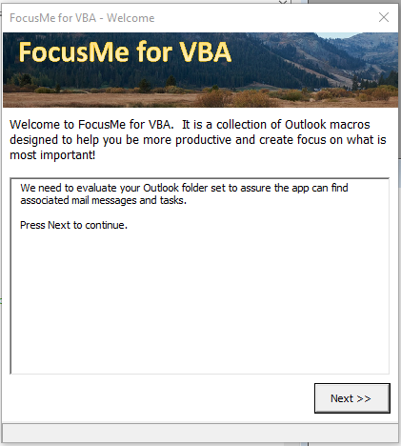

Figure - Welcome Window

It will take the user through two start up steps:

1. ***Index Folders:*** the first step is to identify and index the user’s Outlook folders for use in expediting item queries. This will make finding email, tasks, and appointments faster. See the Settings section for how to do this periodically as you add and remove Outlook folders.
2. ***Sync Projects to Categories:*** the second step will create an initial project list from the user’s Outlook categories (i.e. the colored labels found in the Master Category List). If you use categories, this is a great way to get a head start on managing projects via FocusMe. This step is **optional** and can be skipped by canceling the Welcome window.

Once this process has been completed, the Welcome window will not be presented again.

## FocusMe Task Pane

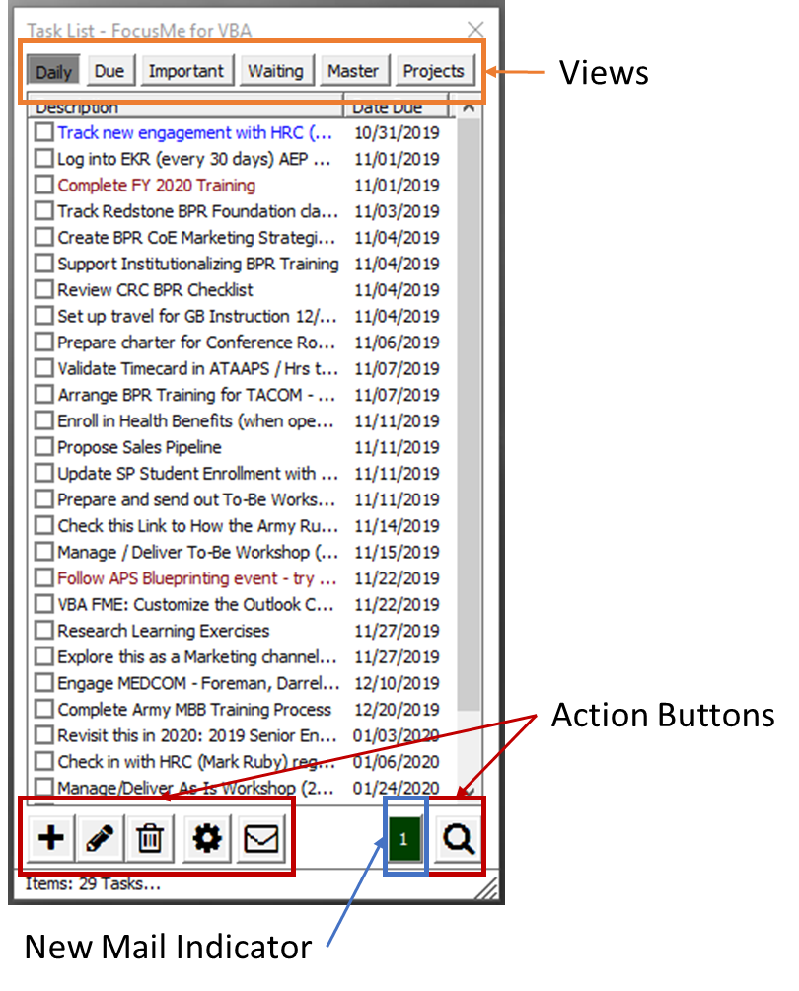

Figure 3 – FocusMe Task Pane

### Views

The FocusMe Task Pane provides 5 main views for tasks. They are represented by first five tab buttons at the top of the window: Daily, Due, Important, Waiting and Master (see more in “Managing Tasks”).

* Daily View: Outlook tasks that have due dates
* Due View: Outlook tasks that are overdue
* Important: Outlook tasks with a set High Priority flag
* Waiting: Outlook tasks that have a status of “Waiting on someone else”
* Master: Outlook tasks that have no due date

The Projects View lists the user defined projects which are synchronized with Outlook’s Master Category List (MCL). The Outlook categories are used within each Outlook item (e.g. Message, Task, Appointment, etc.) allowing the user to assign a category and color to the item, and group those items in various Outlook views.

### Action Buttons

The actions buttons enable the creation (plus), edit (pencil), and deletion (trashcan) of the items within the view. When tasks are shown on the FocusMe Task Pane, the envelope button launches a separate view enumerating the email messages that are linked or tagged to the selected task. The cog button launches the Settings window, and the search button filters the active list based on the text entered into the search box (which is presented when the search button is selected).

### New Mail Indicator

The green button is visible when one or more email messages are posted to Outlook Inbox folder. This allows the user to minimize the Outlook window but keep an eye on the incoming messages count. This can help to reduce email distraction and enable better focus on doing the work.

The FocusMe Task Pane can be setup to automatically start when Outlook starts via the Setting window. When enabled, the task pane will remain visible even when Outlook is minimized. If the task pane is started after Outlook starts, it will minimize along with the Outlook window.

## Creating Projects

When the Projects view is selected, a list of the user projects is presented:

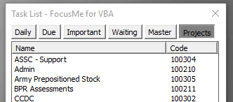

Figure 4 – Projects View Snippet

The Action Buttons can be used to create new projects and edit and remove existing projects. I personally like using codes and project names, although it is not mandatory (can be turned on/off in the project window). Using codes allows a way to group projects together by sorting on the Code column (click on the Code column header).

### Create a new Project

By selecting the plus Action Button while viewing the list of projects, a new Project window is presented.

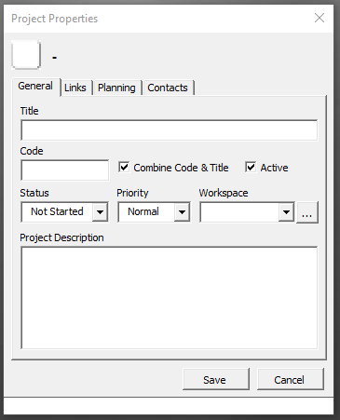

Figure 5 – New Project Dialog

There are four tabs within the Project window; General, Links, Planning and Contacts. When creating a new project, it easiest to focus on the General tab. By completing the information on that tab you will have the minimum information needed to successfully use the project as an organizing mechanism for the Outlook items.

The General tab has these fields:

* **Title** – the title or name of the project
* **Code** – a string of characters (numbers or letters) to help group projects together
* **Combine Code & Title** – a true/false flag that sets how the project is represented in Outlook’s Master Category List (MCL), if True includes the code in the MCL
* **Active** – a true/false flag used to remove the project from view without deleting it from the tool
* **Status** – a dropdown list of options showing the status of the project, it follows the same nomenclature as Outlook’s task statuses, i.e. Not Started, In Progress, Deferred, Waiting, and Complete
* **Priority** – a dropdown list of options representing the project’s priority, it follows the same nomenclature as Outlook’s priority/importance selections, i.e. Low, Normal, High
* **Workspace** – a method for grouping projects, specifically used in Time Tracking
* **Project Description** – a short description of the project, e.g. what might be used in a project charter

Additionally, the button in the upper left corner can be selected to assign a color to the project.

### Edit a Project

By selecting the pencil Action Button while viewing the list of projects, the selected project in the list will be presented in a Project window. The fields described in ‘Create a Project’ can be changed and updated.

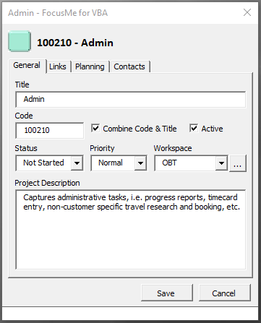

Figure – Edit a Project

If the Title or Code is changed, Outlook’s MCL will also be updated. Keep in mind that Outlook items assigned to the ‘old’ title or code may be stranded, i.e. they will continue to show up under the old category. You can use the Outlook task views, grouped by category, to quickly see the tasks that are still assigned to the old category.

### Delete a Project

By selecting the trashcan Action Button while viewing the list of projects, the selected project in the list can be deleted after responding ‘yes’ to a confirmation message.

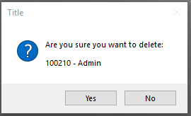

Figure - Project Deletion Confirmation Dialog

The project will be removed from the user’s data store and cannot be recovered. The associated Outlook category will be removed from the Master Category list. Any Outlook items assigned to the Project’s Outlook category will remain categorized to the project. When viewing an assigned Outlook item, the category will remain with the color removed. If the MCL edit dialog is selected via Outlook, the assigned category will have a statement next to the category name in parenthesis, i.e. (not in Master Category List).

### Manage a Project

There are two views within the Project window that show a filtered list of tasks and contacts assigned to the selected project.

1. The Planning tab contains tasks found in all ‘Task’ folders assigned to the Project, i.e. the task’s category references the project’s name.
2. The Contacts tab contains people in all ‘Contact’ folders assigned to the Project, i.e. the contact’s category references the project’s name.

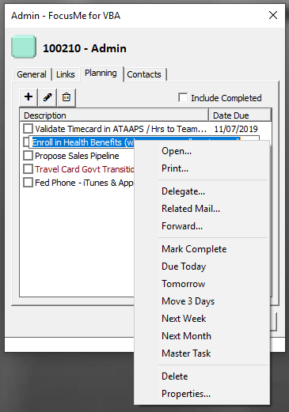

Figure - Project Window | Planning Tab

Using the buttons at the top of the task list allows tasks to be added that are automatically assigned to the project, edited or deleted. When a task is right-clicked, a context menu is presented to allow quick actions to be taken on the selected task.

|  |  |
| --- | --- |
| Open | Opens the Outlook task window |
| Print… | Prints the task and its properties |
| Delegate… | Future Capability | will assign the task to someone else |
| Related Mail… | Opens a new window displaying email tagged to the task |
| Forward… | Prepares an email with the task description in the subject |
| Mark Complete | Marks the task completed |
| Due Today | Reassigns the task’s due date to the present date |
| Tomorrow | Moves the task’s due date to tomorrow |
| Move 3 Days | Moves the task’s due date out 3 business days |
| Next Week | Reassigns the task’s due date to one week later |
| Next Month | Moves the task’s due date to one month later |
| Master Task | Removes the task’s due date – moved to the Master task list |
| Delete | Deletes the selected task |

*Table 1 – Task Item Context Menu*

|  |  |
| --- | --- |
|  | When using the **Related Mail** feature – the tool will query every mail folder looking for messages linked to the specified task. This may make Outlook appear that it is hung, please wait for it to finish. |

When “Include Completed” at the top of the task list is checked all tasks, done and undone, assigned to the project will be presented.

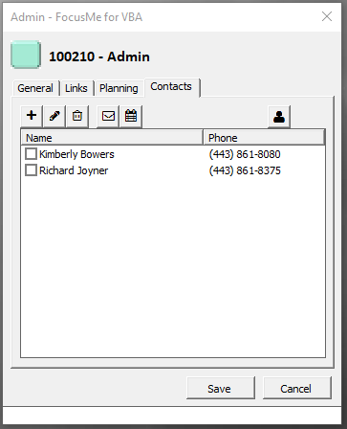

Figure - Project Window | Contacts Tab

Using the buttons at the top of the contact list allows people to be added that are automatically assigned to the project, edited or removed from the project. The envelope button is used to send an email to one or more contacts (use the checkboxes to pick the selected contacts). The calendar button is used to send a meeting invite to one or more contacts.

## 5D Processing Email

A key technique to use in taming email is to process email, not read it. When you process email, you limit the amount of time spent in your Inbox (time away from accomplishing progress towards your goals). FocusMe supports 5D processing, i.e. Do, Defer, Delete, Delegate and Drawer.

|  |  |
| --- | --- |
| Do | If you can respond to the email inside of two minutes, then Do is the right option |
| Defer | For emails you must take action, Defer is the best choice |
| Delete | If an email doesn’t align to any of your goals, it’s a good practice to delete it |
| Delegate | Email that are received that require action from someone else, delegate |
| Drawer | Some email you need for reference, they should filed to a folder, put it in the Drawer |

*Table 2 – 5D Processing*

FocusMe adds a new ribbon button to the Home tab (when viewing an email folder, e.g. Inbox).

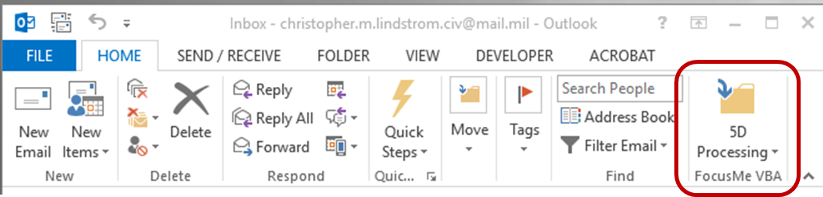

Figure - Mail Home Tab | 5D Button

When selecting an email, the 5D button provides the options:  
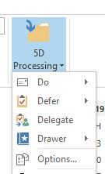5D – Do

* ***Reply – Tracked***: By selecting this option a reply email is generated for which you can fashion your response. When Send is pressed, a new task is generated, that is linked to the sent email. The new “tracking task” can be used to monitor the email thread and take summary notes for each correspondence in the tasks notes field. This can serve as a nice reminder as the task is worked until completion.
* ***Forward – Tracked***: Same flow as the reply, however, a forward email is generated instead of a reply email.

***Note:*** If the email management settings include filing the email upon the Do event, there may be a slight delay in editing (typing with no response) the newly created reply or forward message.

A little later we will show you how to link an existing email conversation to an existing task.

### 5D – Defer

* **To Task:** A new task is created from the originating email. The email is tagged and embedded in the new task and the email filed according to the Drawer rules set in the Settings. The newly created task is used to manage the action taken based on the email’s request or content.
* **To Schedule**: A new calendar event (appointment) is created from the originating email. The email is embedded in the newly created appointment and the email is filed according to the Drawer rules set in the Settings dialog.

### 5D – Delegate

A reply or forward email is created from the originating message. The email is tagged and embedded in a new task that is assigned to the email’s recipient(s). THIS FUNCTION IS A FUTURE CAPABILITY.

### 5D - Drawer

* **File in Folder**: The email is filed according to the Drawer rules set in the Settings.
* **File in Journal**: A new Outlook Journal Item is created from the originating email. The email is embedded in the new journal item and the email filed according to the Drawer rules set in the Settings.
* **File in Windows Folder**: The email is filed in the appropriate Windows folder as a .msg file. The Windows folder is set via the Project Properties window, Link tab. THIS FUNCTION IS A FUTURE CAPABILITY.

## Managing Tasks

The main purpose of the FocusMe Task Pane is to always keep your To Do items in front of you. Each day adjustments will need to be made to re-plan how you intend to get your tasks accomplished.

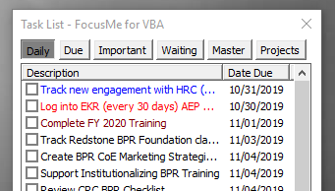

Figure – Task Pane Snippet

When a task is right-clicked a context menu is presented, see Table 1 for a description of the options. There are several ways to quickly update the due date, e.g. set to Today, Tomorrow, Next Week, etc. Additionally, the task can be opened for further discovery, investigation and assessment.

The tasks are color coded to provide visual cues for quick planning decisions. Red tasks are overdue, blue tasks are due today, black tasks are due in the future, and magenta tasks are tasks marked as high importance. Additionally, the built-in filters, e.g. Due, Important and Waiting, can provide quick work for re-planning, focus and execution.

One last note on planning and re-planning tasks. FocusMe can provide sufficient capability to modify due dates for your tasks. However, if you’d like a more visual way to move tasks across date, use Outlook’s native Calendar view and show the task window at the bottom of the calendar.

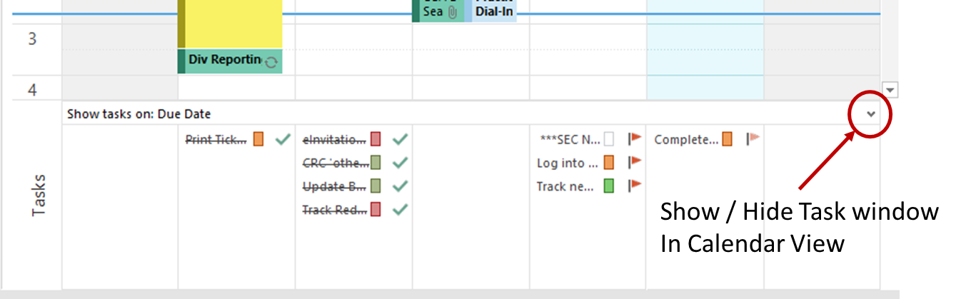

Figure - Task Window - Outlook Calendar

### Search

Once processing your Inbox becomes a habit, it’s common to end up with quite a few tasks on the task list. In order to make it easier to find the task you’re tracking on a specific subject, there is a search function built into the task pane.

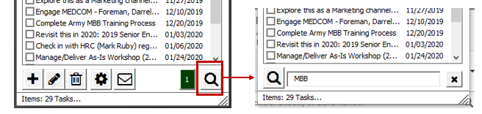

Figure 11 - Task Search

Pressing the magnifying glass reconfigures the Action Buttons, providing a search window to enter text that can be used to find one or more tasks matching the search word(s). It’s a basic keyword search based on the text in the task’s subject and notes. It searches the tasks in the currently displayed list. If you know you assigned a due date, you would find the task on the Daily tab. If no due date, search on the Master tab. You can exit search mode by pressing the X button.

If you need more sophisticated searching abilities, use the Outlook native Task views.

### Related Mail

Tracking action can get complicated. Many tasks can last over a period of months, and it can be difficult to remember the detail in a critical moment (e.g. when someone calls). The Related Mail feature combined with an organized way of tracking actions using a task can be vital to staying on track.

First let’s introduce Related Mail –

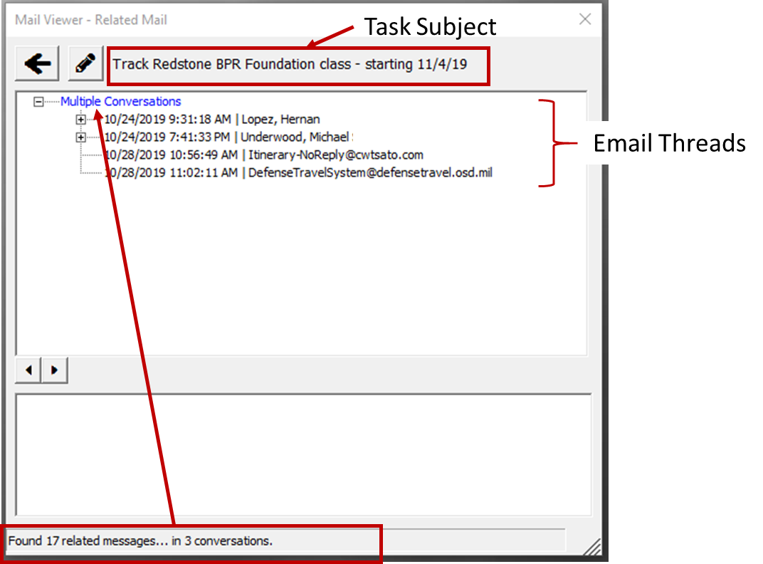

Figure - Related Mail Example

By selecting a task in the task list, and then using the Related Mail button or context menu item, the Mail Viewer is launched.

|  |  |
| --- | --- |
|  | When using the **Related Mail** feature – the tool will query every mail folder looking for messages linked to the specified task. This may make Outlook appear that it is hung, please wait for it to finish. |

In the example above, there was a need to coordinate training delivery at a specific location on a specific date. There were several players involved, i.e. training lead, supporting trainers, training coordinator, and several people from the receiving organization. Anyone can start a new email conversation about this topic. In fact, there 17 emails in 3 different conversations concerning this task.

When you expand the conversations, it can look intimidating:

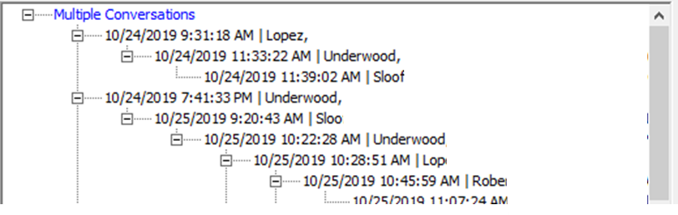

Figure - Related Mail Snippet

As you can see there were several branches to the conversations (and remember you can only see the messages upon which you are included). Consider trying to remember where these emails are filed and what days they were sent or received. In this example, this task had a short lifecycle, about two weeks.

Here’s a screenshot of the Task:  
  
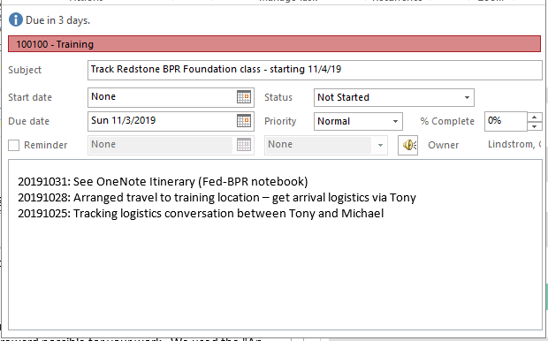

You can see that the tracking task started based on a logistics conversation. Subsequent emails were linked back to this task for tracking and information purposes. Once the travel was arranged, it was recorded in the task notes. And as additional logistics presented themselves, e.g. participating students, directions to the training location, etc. were received, they were recorded within OneNote and referenced back within the task notes.

### Linking Existing Conversations

Often email is received that is related to one of our tasks, but we didn’t initiate the email thread. When that happens FocusMe supports a drag and drop motion to connect an email in an Outlook folder (e.g. Inbox) to a Task that is part of Task List.

Simply grab the email of interest, drag it over to the FocusMe task list and release the email onto the task of interest.

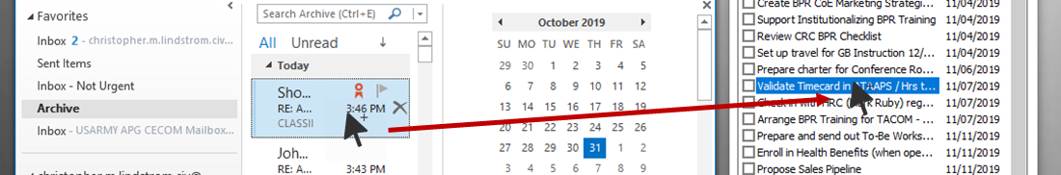

Figure - Linking an Email

FocusMe then “tags” the email by placing a unique code at the bottom of the originating email. If that email gets replied to or forwarded, the tag will follow it through each recipient. The Mail Viewer, described in the previous section, searches your email folders looking for the task’s tag. Each tag is unique to its owning task.

|  |  |
| --- | --- |
|  | When using the **Link Email** feature – if the email message that is to be linked to a task is encrypted/signed, Outlook can look like its hung. Hang in there, the tool is attempting to tag the originating email and Outlook is figuring out how to let the email get tagged. |

## Time Tracking

If your organization requires you to track time your time, FocusMe has a built-in function that totals up the time recorded using the appointments on your calendar. The analysis can be displayed via the Timecard or the individual records can be exported to a .csv file.

The Timecard can be accessed on the Calendar Home Tab – the timecard will automatically set its start and end date based on the dates presented on Outlook’s view.

### Calendar Home Tab



Figure - Timecard Button on the Calendar Ribbon

If you don’t see the Timecard button, please refer to the installation instructions at the beginning of the document.

The Timecard window presents the time record totals by project or workspace and date. It includes grand totals for each row and column. The dates can be modified using the Start and End date fields and selector buttons. To apply the new dates, press the Refresh button. If the Group By dropdown is changed the records will be refreshed automatically. The time records can be export to a .csv file by selecting the Export button.

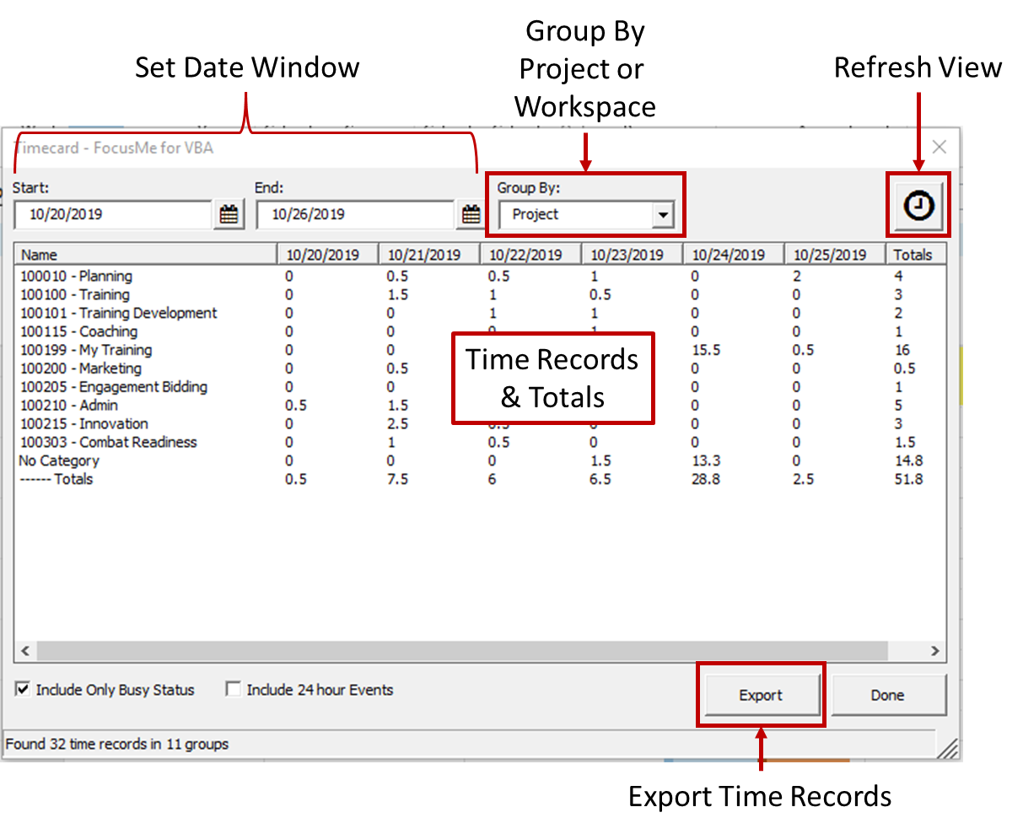

Figure - Timecard grouped by Project

|  |  |
| --- | --- |
| Start | Specifies the beginning date for the timecard |
| End | Specifies the end date for the timecard |
| Group By | Groups the time records by Project or Workspace |
| Include Only Busy Status | When selected includes only appointments marked as busy, if not will analyze all appointments within the date window |
| Include 24-hour Events | When selected includes All Day appointments for a duration of 8 hours |

*Table 3 – Timecard fields*

## Settings – Application Options

The Settings window includes administrative tools and allows the user to tailor the FocusMe experience.

|  |  |
| --- | --- |
|  |  |

### Home Tab

#### General Settings

* ***Show Task Window when Outlook Starts:*** When checked, the FocusMe Task Pane will be presented every time Outlook is started. If you would like to keep the task pane visible when Outlook is minimized, this option must be selected.
* ***Enable Application Events:*** The application is built to “listen” to Outlook events, i.e. when a new email arrives, a new window is created, etc. If unchecked, reply/forward tracking tasks and auto-filing (defined in Move Mail Rules) will not function.
* ***About Button***: Presents information describing the application name, version, and support contact.

#### Collections

* ***Match Button***: Pressing the button will reset the FocusME VBA projects to match the current Outlook categories.
* ***Index Button***: The application creates a list of the Outlook folders and their default items to expedite queries and mail searches. Selecting this button will update the index. If folders created or deleted, it is a good practice to update the index.

#### Tools

* ***Reset Button***: The FocusME Task Pane remembers its last location, selecting the Reset button will move the task pane to its default location.

### E-Mail Tab

#### Rules

* ***Do not move mail in Sent Items folder***: Sometimes its important to forward an email that we’ve already sent. If the Do-Reply event is checked, any email replies or forwards auto-file the originating email message. By checking this box, if an email message in the Sent Items folder is replied to again, or forwarded, the originating message will not be moved to a different folder.

#### Events

* ***Do Not Move Mail***: When an email is processed (using the 5Ds) the email will not be moved from its source folder.
* ***Move Mail on All Events***: Once the email gets processed, it will be automatically filed in the folder specified in the Destination folder setting.
* ***Move Mail on specific Events***: This option allows the user to specify which of the 5D event(s) allow the mail to moved after it is processed.

#### Location

* ***Folder Button:*** The folder button presents a list of Outlook folders where one can be selected to be the default location for email that gets auto-filed per the Move Mail Rules. In the latest versions (2013+) of Outlook, an Archive folder is created by default and works in tandem with Outlook’s built in Archive command. W e recommend referencing that folder.

# More Information

## Reference Materials

Additional pertinent concepts, information and access to the VBA code:

|  |  |
| --- | --- |
| **GitHub Repository** | The FocusMe for VBA code is open source and can be viewed and leveraged via GitHub: <https://github.com/cmlindstrom/FocusMe-for-VBA> |
| **Zero Inbox** | Inbox Zero is an approach to managing email to keep your email Inbox clear or nearly empty consistently. <https://whatis.techtarget.com/definition/inbox-zero> |
| **5D Email Processing** | The email inbox is a "holding area" for work. A queue or bin that contains work waiting for us to do something or provide a response causing anxiety, frustration, lost time, and missed opportunities. 5D email processing is the cure. <http://www.ceptara.com/blog/FocusMe-5DProcessing> |
| **Seven Habits** | The 7 Habits of Highly Effective People by Stephen Covey, first published in 1989, presents an approach to being more effective in attaining goals. It provides a foundational mindset for better utilizing the FocusMe approach. <https://en.wikipedia.org/wiki/The_7_Habits_of_Highly_Effective_People> |
| **Getting Things Done (GTD)** | David Allen’s GTD method rests on the idea of moving planned tasks and projects out of the mind by recording them externally and then breaking them into actionable work items or tasks. <https://en.wikipedia.org/wiki/Getting_Things_Done> |

## FocusMe for Outlook - .net Version

*Get Organized, Drive Focus, Achieve your Dreams*

Ceptara's FocusMe application is a Microsoft Outlook 2010, 2013 & 2016 add-in designed to help you and your team achieve greater focus. It helps you get more organized via features include including 5D email processing, organizing your mail, tasks, appointments, documents, and notes by Project, task planning support, and time tracking and timecards. It includes task planning tools such as Gantt charts, MindMaps, Kanban Planner, and free/busy scheduling. You can track action using email delegation and follow up tasks that are automatically linked to your contacts.  
[Learn More](http://www.ceptara.com/products/focusme/download?channel=dodvbafme&rdnid=96)